# 05. Front End Design

*In the world of Quality Assurance, QA specialists are digital architects. They use HTML and CSS to craft elegant test cases and perfect test environments. With precision, they structure content, ensuring flawless web applications one test at a time. Embrace your role and let your creativity shine in the realm of quality assurance.*

## Creating a Simple Web Page:

* Create a Web Page like the one presented in the Screenshot:

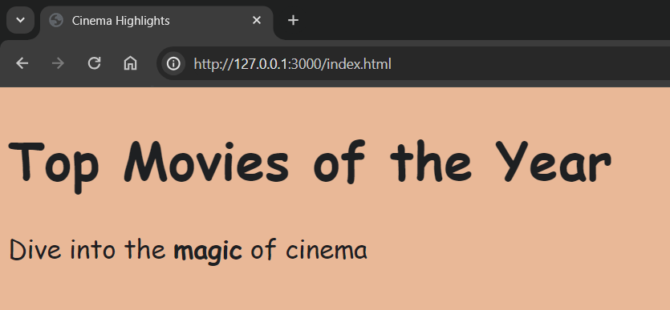

## Instructions & Requirements:

* You have been provided with a **.zip file** containing an **index.html** and **style.css** file.
* **Extract** the contents of the **.zip** file to a **folder of your choice**.
* Open the **index.html** file in a **text editor** or an integrated development environment (**IDE**), for example **Visual Studio Code**.
* Make the following changes to the **index.html** file:
  + Change the title of the web page to **"**Cinema Highlights**"**.
  + Modify the text within the **<h1>** tag to say **"**Top Movies of the Year**"**.
  + Update the text within the **<p>** tag to say **"**Dive into the magic of cinema". The phrase **"magic"** should be **bold**.
* Open the **style.css** file in a text editor or an integrated development environment (IDE).
* Write the necessary **CSS rules** to achieve the following **styling**:
  + Set the **background** color of the **body** element to **#e9b897**
  + Set the **font size** of **all elements** to **26 pixels**.
  + Set the **font family** for **all elements** to **'Comic Sans MS', cursive**.
  + Set the **text color** of **all elements** to **#1e2022**

## How to Send Solutions in Judge?

* Make a **zip** archive of your solution by **right-clicking on the index.html file.**

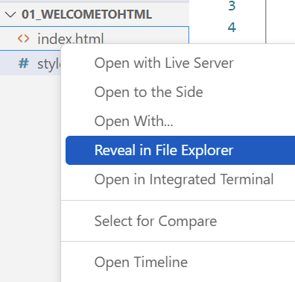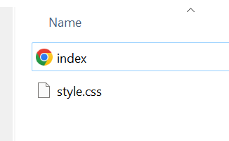

* **"CTRL + A"** to select both files and Compress to ZIP file:

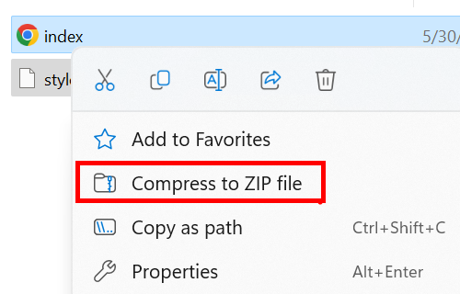

* **Upload** the **compressed file** to Judge and **Submit**.